April
2019
Roster  We depart from Salamanca Place except on Saturday afternoons after 2.30pm when we depart from outside Brooke St Pier.  Our first tour departs at the time shown below and the final tour concludes at the times shown. Tours depart on demand. Bookings are definitely recommended. | 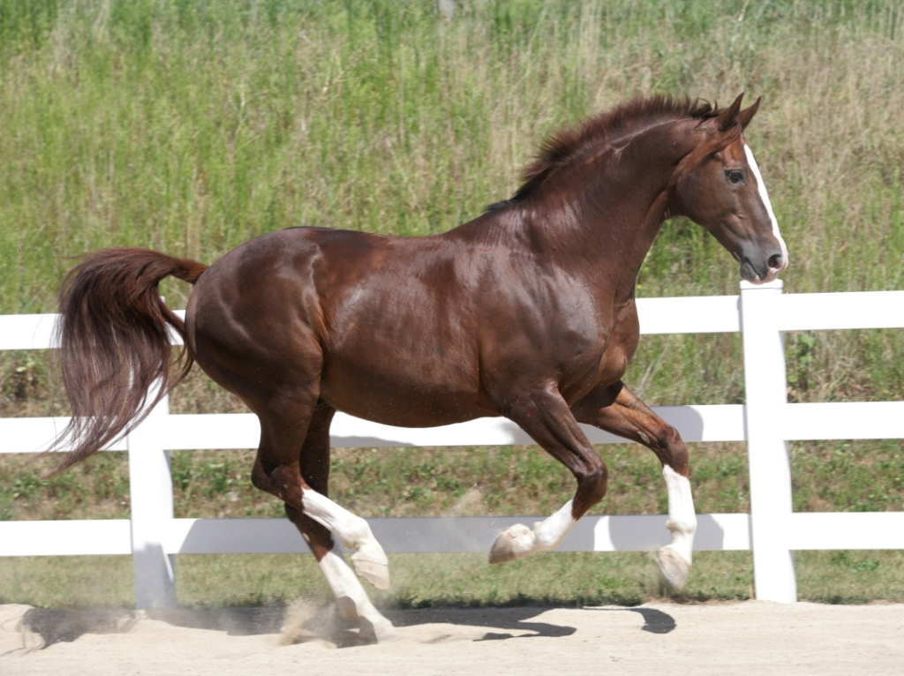
Sunday | Monday | Tuesday | Wednesday | Thursday | Friday | Saturday
 | 1 | 2 | 3 | 4 | 5 | 6
 | NOT WORKING |  |  | 11AM TO 5.30PM  CRUISE SHIP IN PORT |  | 11AM TO 5.30PM
 | 8 | 9 | 10 | 11 | 12 | 13
12PM TO 6.00PM | 11AM TO 5.30PM  CRUISE SHIP IN PORT | NOT WORKING |  | 12PM TO 6.00PM | 12PM TO 6.00PM | 11AM TO 5.30PM
14 | 15 | 16 | 17 | 18 | 19 | 20
12PM TO 6.00PM | 12PM TO 6.00PM | NOT WORKING |  | 12PM TO 6.00PM | 12PM TO 6.00PM  EASTER | 11AM TO 5.30PM  EASTER
21 | 22 | 23 | 24 | 25 | 26 | 27
12PM TO 6.00PM  EASTER | 12PM TO 6.00PM  EASTER | NOT WORKING |  | NOT WORKING  ANZAC DAY | NOT WORKING - WEATHER | 11AM TO 5.30PM
28 | 29 | 30
12PM TO 6.00PM | NOT WORKING

May
2019

Roster

We depart from Salamanca Place except on Saturday afternoons after 2.30pm when we depart from outside Brooke St Pier.

Our first tour departs at the time shown below and the final tour concludes at the times shown. Tours depart on demand. Bookings are definitely recommended.

Sunday | Monday | Tuesday | Wednesday | Thursday | Friday | Saturday
 |  |  | 1 | 2 | 3 | 4
 |  |  | NOT WORKING – AGFEST ON 2 MAY |  | 12PM TO 6.00PM | 11AM TO 5.30PM
5 | 6 | 7 | 8 | 9 | 10 | 11
12PM TO 6.00PM | NOT WORKING |  |  | 12PM TO 6.00PM | 12PM TO 6.00PM | 11AM TO 5.30PM
 | 13 | 14 | 15 | 16 | 17 | 18
12PM TO 6.00PM | NOT WORKING |  |  | 12PM TO 6.00PM | 12PM TO 6.00PM | 11AM TO 5.30PM
 | 20 | 21 | 22 | 23 | 24 | 25
12PM TO 6.00PM | NOT WORKING – TAS TOURISM CONFERENCE 22 & 23 MAY |  |  |  | 12PM TO 6.00PM | 11AM TO 5.30PM
 | 27 | 28 | 29 | 30 | 31
12PM TO 6.00PM | NOT WORKING |  |  | 12PM TO 6.00PM | 12PM TO 6.00PM

