April
2019
Roster  We depart from Salamanca Place except on Saturday afternoons after 2.30pm when we depart from outside Brooke St Pier.  Our first tour departs at the time shown below and the final tour concludes at the times shown. Tours depart on demand. Bookings are definitely recommended. | 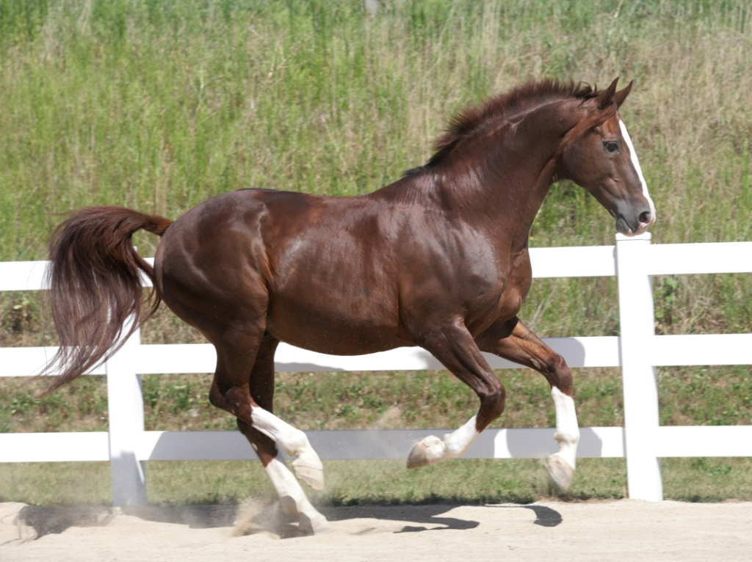
Sunday | Monday | Tuesday | Wednesday | Thursday | Friday | Saturday
 | 1 | 2 | 3 | 4 | 5 | 6
 | NOT WORKING |  |  | 11AM TO 5.30PM  CRUISE SHIP IN PORT |  | 11AM TO 5.30PM
 | 8 | 9 | 10 | 11 | 12 | 13
12PM TO 6.00PM | 11AM TO 5.30PM  CRUISE SHIP IN PORT | NOT WORKING |  | 12PM TO 6.00PM | 12PM TO 6.00PM | 11AM TO 5.30PM
14 | 15 | 16 | 17 | 18 | 19 | 20
12PM TO 6.00PM | 12PM TO 6.00PM | NOT WORKING |  | 12PM TO 6.00PM | 12PM TO 6.00PM  EASTER | 11AM TO 5.30PM  EASTER
21 | 22 | 23 | 24 | 25 | 26 | 27
12PM TO 6.00PM  EASTER | 12PM TO 6.00PM  EASTER | NOT WORKING |  | NOT WORKING  ANZAC DAY | NOT WORKING - WEATHER | 11AM TO 5.30PM
28 | 29 | 30
12PM TO 6.00PM | NOT WORKING

May
2019
Roster  We depart from Salamanca Place except on Saturday afternoons after 2.30pm when we depart from outside Brooke St Pier.  Our first tour departs at the time shown below and the final tour concludes at the times shown. Tours depart on demand. Bookings are definitely recommended.  **Macquarie Point Open Day Free carriage rides from 11am-1pm | 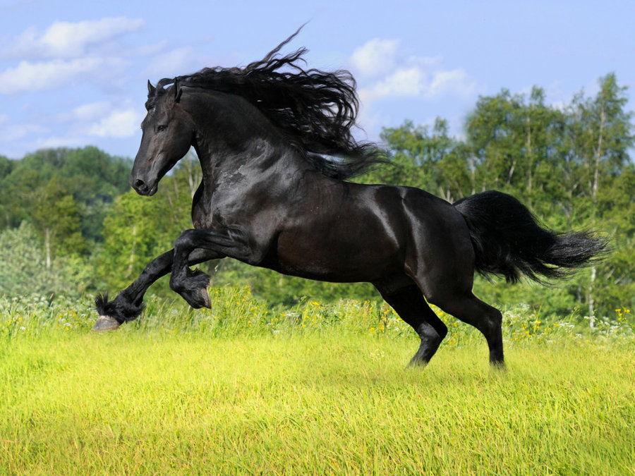
Sunday | Monday | Tuesday | Wednesday | Thursday | Friday | Saturday
 |  |  | 1 | 2 | 3 | 4
 |  |  | NOT WORKING – AGFEST ON 2 MAY |  | 12PM TO 6.00PM | 11AM TO 5.30PM
5 | 6 | 7 | 8 | 9 | 10 | 11
12PM TO 6.00PM | NOT OPERATING |  |  | 12PM TO 6.00PM | 12PM TO 6.00PM | 11AM TO 5.30PM
 | 13 | 14 | 15 | 16 | 17 | 18
12PM TO 6.00PM | NOT OPERATING |  |  | 12PM TO 6.00PM | 12PM TO 6.00PM | 11AM TO 5.30PM
 | 20 | 21 | 22 | 23 | 24 | 25
12PM TO 6.00PM | NOT OPERATING – TAS TOURISM CONFERENCE 22 & 23 MAY |  |  |  | 12PM TO 6.00PM | **11AM TO 5.30PM
 | 27 | 28 | 29 | 30 | 31
12PM TO 6.00PM | NOT OPERATING |  |  | 12PM TO 6.00PM | 12PM TO 6.00PM

June
2019
Roster  We depart from Salamanca Place except on Saturday afternoons after 2.30pm when we depart from outside Brooke St Pier.  Our first tour departs at the time shown below and the final tour concludes at the times shown. Tours depart on demand. Bookings are definitely recommended. During Dark Mofo (9-23 June), we may need to finish early due to restrictions. | 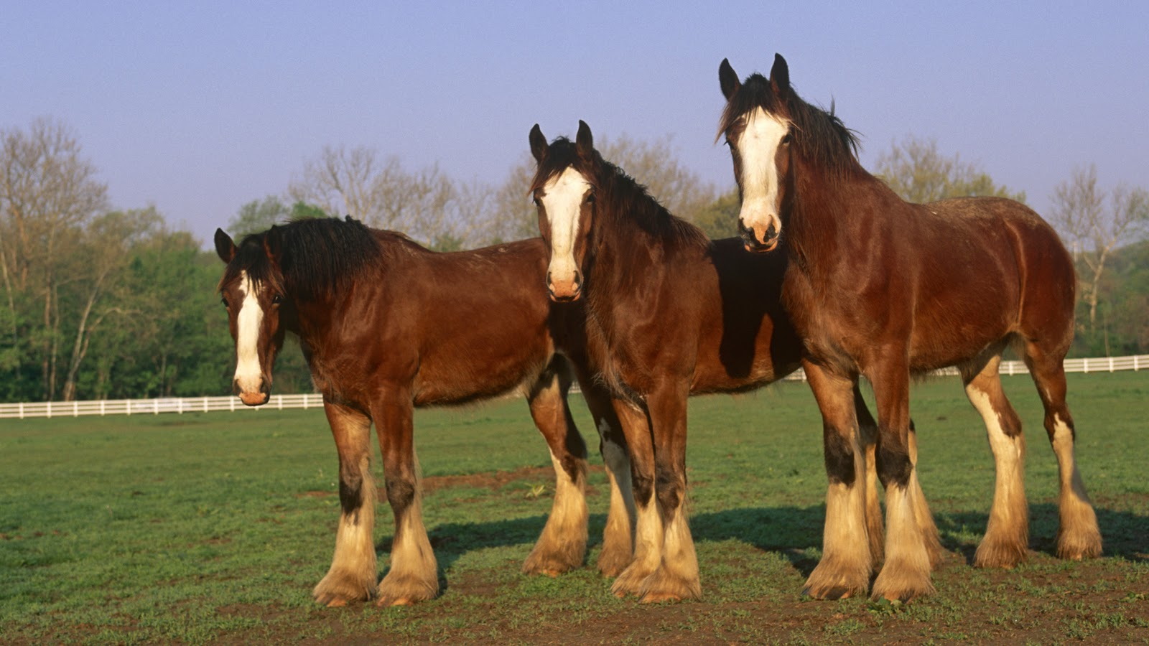
Sunday | Monday | Tuesday | Wednesday |  | Thursday | Friday | Saturday
 |  |  |  |  |  |  | 1
 |  |  |  |  |  |  | 11AM TO 5.30PM
2 | 3 | 4 | 5 |  | 6 | 7 | 8
12PM TO 6.00PM | NOT OPERATING |  |  |  | 12PM TO 6.00PM | 12PM TO 6.00PM | 11AM TO 5.30PM
9 | 10 | 11 | 12 |  | 13 | 14 | 15
12PM TO 6.00PM | 12PM TO 6.00PM  QUEENS B’DAY | NOT OPERATING |  |  | 12PM TO 6.00PM | 12PM TO 6.00PM | 11AM TO 5.30PM
16 | 17 | 18 | 19 |  | 20 | 21 | 22
12PM TO 6.00PM | NOT OPERATING |  |  | DARK MOFO CRUISE SHIP  PACIFIC EXPLORER  10AM TO 5PM |  |  | 11AM TO 5.30PM
23 | 24 | 25 | 26 |  | 27 | 28 | 29
NOT OPERATING |  |  |  |  | 12PM TO 6.00PM | 12PM TO 6.00PM | 11AM TO 5.30PM
30
12PM TO 6.00PM

